Dido and Aeneas – XLVII
From The Aeneid Book 4 Lines 74-76, 80-83, 86-88

Dido neglects her duties
¹ Nunc ⁶media ³Aenean ⁴secum ⁵per ⁷moenia ²ducit
¹⁰Sidoniasque⁸ ⁹ostentat ¹¹opes ¹²urbemque ¹³paratam,
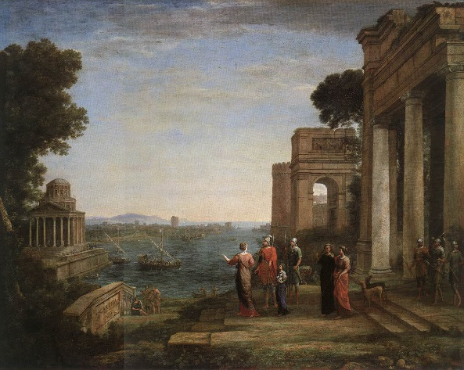
¹incipit ²effari, ⁶mediaque³ ⁵in ⁷voce ⁴resistit;
¹post ²ubi ³digressi, ⁸lumenque⁴ ⁷obscura 6vicissim
⁵luna ⁷premit ¹¹suadentque⁸ ⁹cadentia ¹⁰sidera ¹²somnos
²sola ⁴domo ¹maeret ³vacua ⁷stratisque⁵ ⁸relictis
⁶incubat. ²Illum ¹absens ¹absentem ³auditque ⁵videtque⁴.
³non ²coeptae ⁴adsurgunt ¹turres, / ²non ⁴arma ¹iuventus
³excercet ⁷portusve⁵ ⁸aut ⁹propugnacula ¹¹bello
¹⁰tuta ⁶parant

Translation:
¹Now ²she ²leads ³Aeneas ⁴with ⁴her ⁵through ⁶the (city’s) ⁶midst (and) ⁷walls
⁸and ⁹shows ¹⁰her ¹⁰Sidonian ¹¹wealth ¹²and ¹²the ¹²city ¹³she’s ¹³built:
¹she ¹begins ²to ²speak, ³and ⁴stops ⁵in ⁶mid-⁷voice:
¹Then ²when ³they ³have ³departed, ⁴and ⁵the ⁵moon ⁶in ⁶turn
⁷has ⁷dimmed ⁷her ⁷light ⁸and ⁹the ⁹setting ¹⁰constellations ¹¹urge ¹²sleep,
¹she ¹grieves, ²alone ³in ³the ³empty ⁴hall, ⁵and ⁶lies ⁷on ⁷the ⁷couch
⁸he ⁸has ⁸left. ¹Absent ²from ²each ²other, ³she ³hears ³him ⁴and ⁵sees ⁵him,
¹The ¹towers ²she ²started ³no ³longer ⁴rise, / ¹the ¹young ¹men ²no ²longer
³exercise ⁴in ⁴arms, ⁵or ⁶work ⁷on ⁷the ⁷harbour ⁸or ⁹the ⁹ramparts
¹⁰for ¹⁰safety ¹¹in ¹¹war.

Glossary: (words in the number, case and gender in which they appear in this extract)
Line 1  Moenia: walls, defences  Line 2  Sidonius: Sidonian, Carthaginian, Phoenican  Opes: riches  Line 3  Effari: to speak  Line 4  Vicissim: in turn  Line 5  Permit (premere): dims  Sidera (sidus): constellation | Line 6  Maeret (maerere): she grieves  Stratis (stratum): bed, couch  Line 7  Incubat (incubare): she lies on  Line 9  Portus: harbour, port  Line 10  Tuta: safety

Notes:
1. Aenean: a Greek accusative.
2. Sidonias: Sidon was one of the towns in Phoenicia.
5. The repeated initial's' gives a hushing effect to the line.
7. absens absentem: the meaning of the words contrasts sharply with their position side by side.

